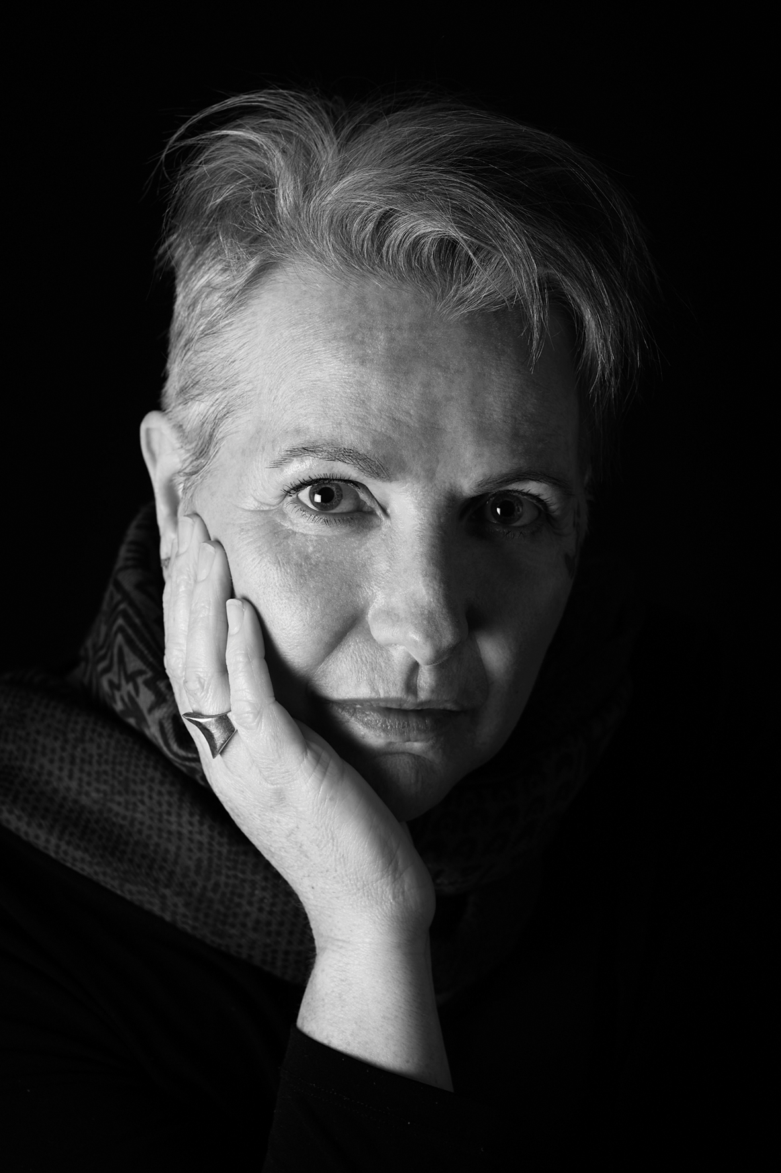
Dorothy-Jane

Dorothy-Jane is an Australian singer, songwriter and blues-harp player. Since 1995 she has performed in and fronted numerous Blues, Jazz and Roots acts, released 8 albums and 2 EP’s.
Her lyrics, performance and presence leave no doubt that she is also a survivor, willing and able to bare her soul through her music. Dorothy-Jane is driven to use her music as a platform to shed light on dark topics.
Her songs draw on her lived experiences – cancer, addictions, mental health, relationships and sexual abuse to name a few. Her lyrics are brave and unpretentious.
"Raw emotion, poetry and humour depict her fighting spirit and determination to get on with life through adversity.”
- Phil Birch-Marston, Artsound FM
“...a singer who's got a voice you'll never forget, and which sounds as classic as any great 20th century female soul-blues singer you could name
- Andy G – Gee-Force, Bridge FM (UK)
Falling helplessly and hopelessly in love with the humble blues-harp over 20 years ago was the impetus for her to begin performing in public. Influenced by Australian harmonica legend, Jim Conway and US “white bluesman” Charlie Musselwhite, among others. Dorothy Jane has developed her own distinctive style.
“...she makes her harmonica strut like an alley cat!”
- Rory McCartney, BMA Magazine
Currently living with Stage 4 metastatic breast cancer has slowed Dorothy-Jane down a bit but hasn’t stopped her recording a thirteen-track concept album, “The Witness” due for digital release mid-January 2020.
Dorothy-Jane has played countless gigs in Australasia playing Blues, Jazz and Folk clubs, house concerts, country halls, fundraisers for breast cancer support, corporate events and private parties.
With over 20 years in the business Dorothy-Jane has a large body of previous recordings available under these pseudonyms - KarismaKatz, DJ Gosper, DeeJay Gosper, Hot Flush Blues Band, Divine Devilles, Dorothy-Jane with Richard Steele, Jeff & Deej – you can find these on most streaming platforms.
PRESS
Album: “The Witness” Dorothy-Jane
“...this is not only essential listening, but it's faultless. From fans of Cleo Laine through Nina Simone to Tom Waits, this is the album you should treasure...” - Andy G – Gee-Force, Bridge FM (UK)

Single: “Speak Out” Dorothy-Jane

“...that’s a great single! Very smooth, and such a soulful voice! Fantastic lower register there too. I love the harmonica and guitar solos! This definitely makes me keen to hear the rest of the upcoming album as well. - Alyssa, Yeah Sweet PR 2019

...The sultry and smoky tones of Dorothy-Jane’s vocals lay the foundations of hope in a message encouraging victims to come forward and ‘Speak Out’. Not only does Dorothy-Jane take us from lows to highs with her vocal range but she provides some sweet bluesy harp playing. Having played for over 20 years, it’s seamless and on point... - Jenny Syratt, Aramintas Attic 2019

Album: "Shut Down" Dorothy-Jane with Richard Steele
"Together Gosper and Steele have created a divine, stripped down, back porch Blues album that proves there is still room for simplicity in contemporary music, and that the Blues are alive, well, and in the palm of her hand." - Chloe Kay Richardson, Rhythms Magazine 2016

Album: "Woman on the Run"
...powerful, dynamic vocals, gutsy harp playing... I don’t think I’ve ever heard such a downright sexy, powerful, version of this old standard [I Just Want to Make Love to You]. This one track alone showcases what an amazing vocal range DJ possesses. - Julie Fox, Reviewer - Sydney Blues Society 2014
DJ Gosper is well known about town as a blues and jazz force of nature. She scored the award for Best Blues/Jazz Artist at the inaugural MAMAs, and achieved national recognition as a vocal finalist in the 2012 Australian Blues Music Awards.
...the husky voice of Dorothy-Jane, belting out the opener Tangled and Dark with her V8 capacity voice. ...Let the Good Times Roll. DJ uses the jiving tune as a platform for a master class in making her harmonica, in which she’s a recognised virtuoso, strut like an alley cat. - Rory McCartney, BMA Magazine 2013

dorothy-jane.com facebook.com/DorothyJaneBlues/

